DATE …………………………….……… STUDENT NO……...……………...…………..…

EXAMINATION CENTRE ……...…………………………………………………………..…………..

THE SHIPPING AND FORWADING AGENTS’ ASSOCIATION OF ZIMBABWE



## FREIGHT FORWARDING AND PRACTICE DIPLOMA

**FINAL EXAMINATION**

**PAPER ONE**

**30 NOVEMBER 2017**

# MULTIPLE CHOICE / TRUE OR FALSE/ SHORT ANSWER QUESTIONS

**TIME ALLOCATION: (1 HOUR)**

**INSTRUCTIONS**

* Remember to write your student number in the space provided on this page and on every other page of this paper. This examination script is the property of SFAAZ and must not be removed from the examination room.
* Answer all questions.
* Each question carries 1 mark.
* This paper carries 40% of the final examination marks.

**FFP Final Nov 2018/ P1 Student No---------------------**

**Short Answer Questions:Write the correct answer in the spaces provided. Each answer carries 1 mark.**

1. **What is a cargo manifest?**

**……………………………………………………………………………………………………………**

**……………………………………………………………………………………………………………**

1. **What is a through bill of lading?**

**……………………………………………………………………………………………………………**

**……………………………………………………………………………………………………………**

1. **Identify one navigable and one non navigable river in Africa.**

**……………………………………………………………………………………………………………**

1. **What is meant by general average?**

**……………………………………………………………………………………………………………**

**……………………………………………………………………………………………………………**

1. **The ICT tool AGV stands for ………………………………………………………………………….**
2. **Who signs the dangerous goods declaration?**

**……………………………………………………………………………………………………………**

1. **Subsidiary risks labels are …………………………………………………………………………..…**

**……………………………………………………………………………………………………………**

1. **Why endorse a bill of lading made out to order?**

**……………………………………………………………………………………………………………**

**……………………………………………………………………………………………………………**

**FFP Final Nov 2018/ P1 Student No---------------------**

1. **What is Indemnity?**

**……………………………………………………………………………………………………………**

**……………………………………………………………………………………………………………**

1. **Where is the delivery point under INCOTERM FCA place?**

**……………………………………………………………………………………………………………**

1. **What does the following image indicate?**

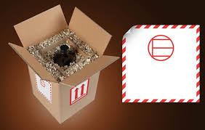

**……………………………………………………………………………………………………….**

**……………………………………………………………………………………………………….**

1. **In air transport containers, what is AMA or AMU?**

**……………………………………………………………………………………………………………**

**……………………………………………………………………………………………………………**

1. **A desiccant is ……………………………………………………………………………………………**

**……………………………………………………………………………………………………………**

1. **Identify two canals that link two different water bodies.**

**……………………………………………………………………………………………………………**

**FFP Final Nov 2018/ P1 Student No---------------------**

1. **What does the acronym SOLAS stand for?**

**……………………………………………………………………………………………………………**

**……………………………………………………………………………………………………………**

1. **Zimbabwe’s rail line gauge is ………………………………………………………………………...**
2. **What is ballast? ………………………………………………………………………..……………….**

**……………………………………………………………………………………………………………**

1. **Part shipment is …………………………………………………………………..…………………….**

**……………………………………………………………………………………………………………**

1. **The acronym TACT stands for ………………………………………………………………………..**

**……………………………………………………………………………………………………………**

1. **What type of label is this?**

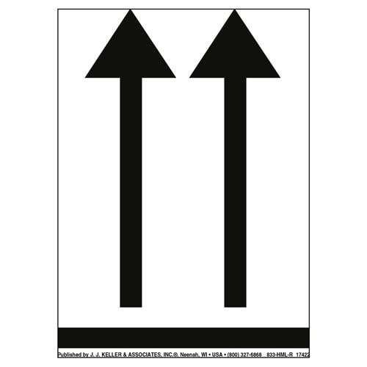

**……………………………………………………………………………………………………………**

**FFP Final Nov 2018/ P1 Student No---------------------**

**True or False Questions – Indicate the correct answer in the brackets provided with either a (T) or an (F). “T” denote True and “F” denotes false.**

1. Sea water is less dense when compared to River water. T / F ( )
2. Goods which are ordered in LCL status would normally move from the premises of the suppliers to the premises of importers within the protection afforded by the ISO container throughout the journey.

T / F ( )

1. A ‘42G1’ ISO container has a higher laden weight to the ‘45G1’ T/F ( )
2. In Southern Africa, the maximum permitted mass for carriage of 6m container by rail is 24 000kg.

T / F ( )

1. Airline ‘chargeable weight’ is either the actual gross mass of a package or its volumetric weight measured in volumetric kilograms of 5 000 cubic centimetres. T / F ( )
2. Co-loading is also known as the ‘Buyers Consolidation’ T / F ( )
3. The Cargo Accounts Settlement Systems (CASS), which is a web-based system that allows airlines and freight forwarders to make only one payment to, or receive one payment from, airlines or cargo agents. T / F ( )
4. A way of achieving a balance of cost and speed is to use an option utilizing both the sea and air transport option . T / F ( T )
5. Motor vehicles fall under class 9 of Dangerous goods. T / F ( T ).

**FFP Final Nov 2018/ P1 Student No---------------------**

1. An ISO Container that has been de-registered and sold to private individual will change the identity (first four letters preceding numbers) to NONE. T / F ( )
2. IRU is the guarantor of the carnet Tier. T/F ( )
3. A barge is self propelled. T/F ( )
4. OTIF is a convention on international transportation of goods by rail. T/F ( )
5. The transferring of a container from rail to road is called transshipment. T/F ( )
6. Multimodal transport means all modes of transport except pipeline.

T/F ( )

**Multiple Choice Questions:** Indicate by inserting the letter of your chosen answer (a,b,c d or e) in the brackets provided. Each question carries 1 mark.

1. Calculate the ‘volumetric weight’ airfreight charge for 1 package measuring 160.3cm x 125.7cm x 100.5 cm.
2. 339 kg
3. 339.3kg
4. 339.5kg
5. 339.4kg
6. None of above ( )
7. Insurance rates on cargo are based on the nature of the risks which the insurance underwriters face in providing cover. Which risks are not included?
8. The nature of the goods themselves e.g. fragility
9. The nature of the transport mode
10. The inclusion of transhipment within the journey
11. The nature of the political climate in any area through which the goods may move.
12. None of above ( )

**FFP Final Nov 2018/ P1 Student No---------------------**

1. What is a Block train?
2. A train consisting of 50 wagons permanently coupled together
3. Operate between two CFSs
4. Each of the rolling stock is able to carry 2 x 6m or 1 x 12m containers
5. All of above
6. A and B above ( )
7. What is the minimum angle and dimension of the below image.

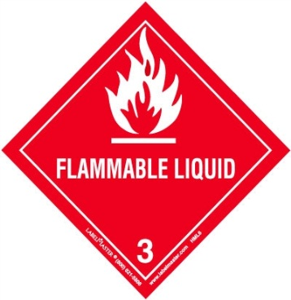

.

1. 45 degrees, 25cm x 25 cm
2. 90 degrees, 250 cm x 250 cm
3. 30 degrees, 35 cm x 35 cm
4. 60 degrees, 25 cm x 25 cm
5. None of above ( )
6. Under CMR convention, what is the maximum claim period on hidden damages?
7. 21 Days including weekends and Holidays
8. 21 Days excluding weekends and Public Holidays
9. 14 Days
10. Once the PODs have been signed the claim falls away
11. Not specified as the CMR deals with the consignments note. ( )
12. In which sea port is Victoria Basin and the Alfred Basin?
13. Richards Bay
14. Cape Town
15. Saldanha
16. Port Elizaberth
17. East London ( )

**FFP Final Nov 2018/ P1 Student No---------------------**

1. A contract of sale that requires the buyer to organize transportation is which of the following?
2. Carrier Haulage
3. Merchant Haulage
4. Subcontracts
5. None of above
6. All of the above ( )
7. When transporting dangerous goods by road, who is responsible for checking and ensuring that the vehicle is properly, plated, placarded, marked and ensuring that the orange plates, placards and marks are kept clean and if they are not required remove or cover plates, placards and marks?
8. Driver and vehicle crew
9. Carrier
10. Inspector
11. Consignor
12. EMA ( )
13. Under international trade, which is the most secure method of payment?
14. Open Account
15. Pre-payment
16. Irrevocable Letter of credit
17. Bill of exchange
18. COD

( )

1. Which is not the cost of inventory?
2. Storage and handling
3. Obsolescence
4. Damage and deterioration
5. Pilferage/shrinkage
6. None of above ( )

**FFP Final Nov 2018/ P1 Student No---------------------**

1. What is the tool used for performance measurement?
2. **Bench marking**
3. **Porters 5 forces**
4. **Value engineering**
5. **STEEPLE**
6. **Lean** ( )

1. **Which wagon is ideal for carrying live animals?**
2. **K – truck**
3. **HSI**
4. **PNN**
5. **L-Truck**
6. **Caboose** ( )
7. **Which shipping line service has been adopted to counter changes in the market?**
8. **Consortium**
9. **Voyage Charter party**
10. **Rationalised Conference**
11. **Simple conference**
12. **Demise** ( )
13. **Which container movement is LCL/FCL**
14. **Groupage**
15. **Buyer consolidation**
16. **Seller consolidation**
17. **Co-loading**
18. **Assemblage** ( )

**FFP Final Nov 2018/ P1 Student No---------------------**

1. **Which sea vessels call at Saldana Bay?**
2. **Cellular**
3. **Ro-Ro**
4. **Tankers**
5. **Bulk carriers**
6. **All of the above** ( )

***\*End of Examination\****